S.M.H.R High School

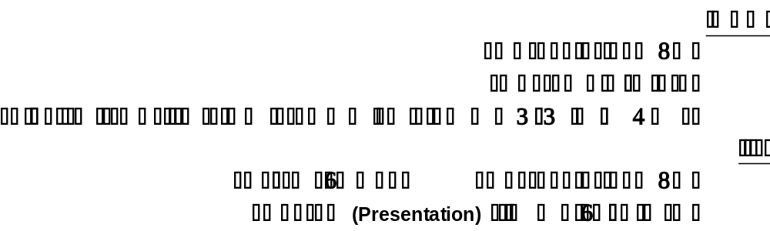
Syllabus for Summer Vacation (2024) for Standard-III (1st Shift)

Computer:
- Learn all things from copy.
Science:
- Learn all work from your copy.
- Draw a solar system in a computer paper also practise for its presentation.
English:
- Learn all things from chapter: “Dorothy meets the scarecrow”, “The wooden Bowl” and poem “Playtime”.
- Make (7 to 8) points on “My School” in a computer sheet, also practice for its presentation.
- Practice for ten pages writing.
Maths:
- Do book work from unit: 02. Exercise: 2a add the following (Q-no: 4, 5, 6, 7, 8 and 9), Exercise: 2b subtract the following (Q-no: 4, 5, 6, 7, 9, 10 and 11)
- Do practice all work from copy.
English Grammar:
- Learn all things from copy.
- Make an assignment on noun and its kinds in a computer paper and also practise for its presentation.
Social Studies:
- Learn all things from copy.
- Make an assignment on the topic “Our Country” write 10 points and also prepare this topic for presentation.

S.M.H.R High School

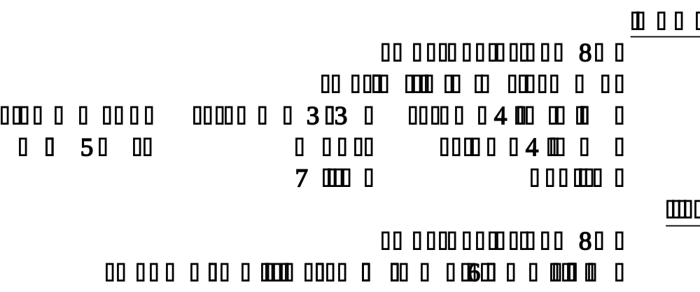
Syllabus for Summer Vacation (2024) for Standard-IV (1st Shift)

Science:
- Learn all work from your copy.
- Draw a diagram of complete and incomplete circuit also practise for its presentation.
English:
- Rad the poem of story, teller and write some sentences in own words on a computer sheet (you can your own story).
- Practice for ten pages writing.
- Read chapters: 1, 2, 3 and 4.
- Learn all things from copy.
Maths:
- Do practice all work from copy.
English Grammar:
- Learn all things from copy.
- Deeply describe what is noun and it’s kinds with example in a computer paper also practice for its presentation.
Social Studies:
- Learn all things from copy.
- What do you know about “Our Country” (Pakistan) and write any five points on each provinces of Pakistan computer, learn all things from copy.

S.M.H.R High School

Syllabus for Summer Vacation (2024) for Standard-V (1st Shift)
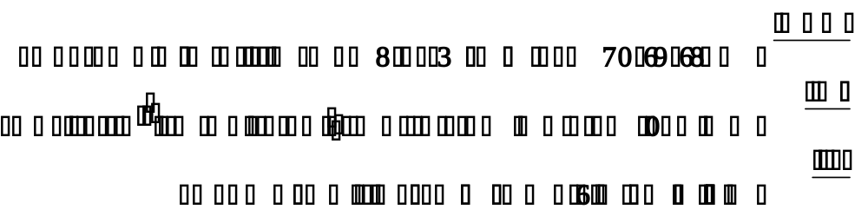

Science:
- Learn all work from your copy.
- What is pollution? Write its types and explain any one kind of pollution with their, causes and effects also draw/paste picture related to the topic. For help see (chapter: Environmental pollution).
English:
- Write a paragraph about ‘the most beautiful thing you have ever seen’ on a computer sheet.
Maths:
- Do practice all work from copy.
- Solve (Q-no: 9 & 10) from book on page 21 from exercise: 1d.
English Grammar:
- Learn all things from copy.
- Write formula and identification of present and past simple tense and also write five example of it. (Book on page: 23)
Social Studies:
- Learn all things from copy.
- Write contribution of any one of the given personalities for the struggle of Independence.
(Chapter 14, The Struggle for Independence)
- Allama Iqbal (b) Qaid-e-Azam Muhammad Ali Jinnah (c) Sir Syed Ahmed Khan
Computer:
- Learn all things from copy.

S.M.H.R High School

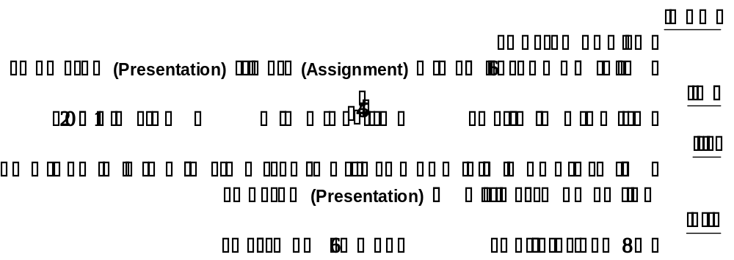
Syllabus for Summer Vacation (2024) for Standard-VI (1st Shift)

Science:
- Learn all work from your journal.
- Write down the names and contributions of three scientists also practice for its presentation from chapter no: 01 (Roll# 1-15).
- Draw a neat and labelled diagram to show the process of “Photosynthesis” also describe this process in your own simple words and prepare this topic for presentation.
- List down a table showing diseases caused by viruses and bacteria. (Book on page: 105)
English:
- Choose a famous personality whom you like or admire. Write down a few points relating to his or her appearance, character, skill, position in life and on.
Maths:
- Do practise all work from your copy.
English Grammar:
- Learn all things from copy.
- Write formula and identification of present and past simple tense and also write five example of it. (Book on page: 23)
Social Studies:
- Learn all things from copy.
- Write 10 points about “The Land and Agriculture of Pakistan and South Asia” on a computer sheet also practice for its presentation.
Computer:
- Learn all things which you have done in your notebook.
S.M.H.R High School

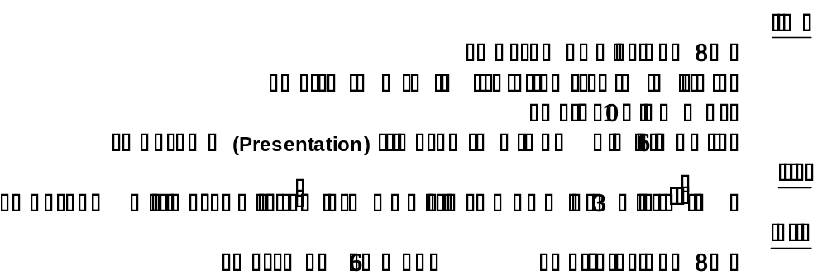
Syllabus for Summer Vacation (2024) for Standard-VII (1st Shift)

Science:
- Learn all work from your copy.
- Make assignment on the topic assigned to the students.
- Coal mining (P: 180) ii. Fossil fuels (P: 182) iii. Hydroelectric power (P: 188)
English:
- Learn all things from copy.
- Read the lesson “The Story of an Invitation” and give your opinion on anyone of three characters of the story. (Presentation)
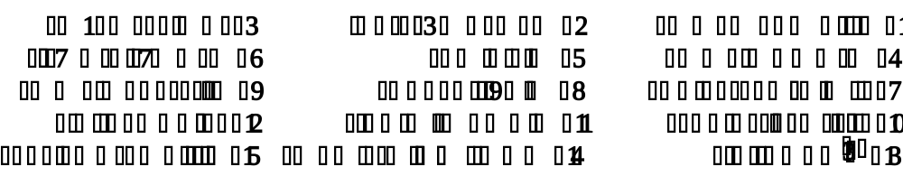
- Translate the sentences and also mention the tense name.

Maths:
- Do practice all work from copy.
Computer:
- Learn all things from copy.

S.M.H.R High School

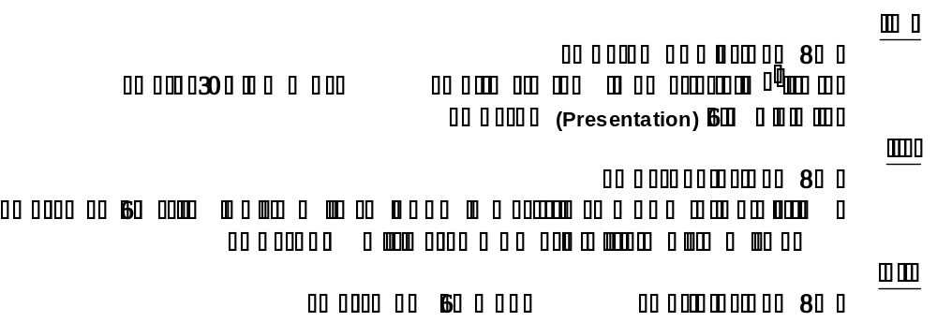
Syllabus for Summer Vacation (2024) for Standard-VIII (1st Shift)

Science:
- Learn all work from your copy.
- Take computer paper. Describe the given topic in detail also draw or paste pictures related to the topic.
- Community (i.e. Garden community, sea shore and field community)
- Environment and Abiotic environment. (i.e. Air, Water, pH)
- Environment and Abiotic environment. (i.e. Light, Temperature, Minerals)
- Environment and Biotic environment. (i.e. Competition and Co-operation)
- Camouflage and Mimicry
English:
- Learn all work from English and English Grammar copies.
- Making a travel brochure. (Details in book on page: 57)
- Write 10 pages in your homework copy.
Maths:
- Do practice all work from copy.
- If U = {0, 1, 2, 3, 4, 5} B = {1, 3, 5} A = {0, 2, 4, 5} then prove the De Morgan’s Law.
- Find the positive square root up to 3 decimal places. a. 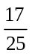 b. 7
- Find the cube root of the following. a. 3375 b. 27000
Social Studies:
- Learn all things from copy.
- Prepare for your presentation on the given topic and write all the required information on the paper. Assignment will be given from chapter: 3 and chapter: 4.
Computer:
- Learn all things from copy.

